**WIP LINE CLEARANCE:**

#### Cubicle and Equipment Assignment

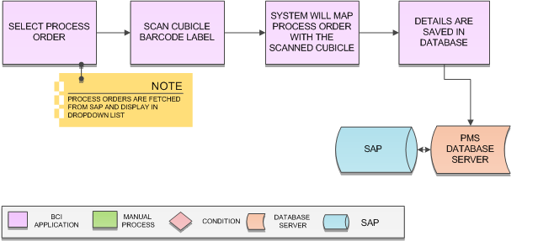

**Activities**

|  |  |
| --- | --- |
| **Module Description** | This module will be used to assign process order to particular Cubicle and Equipment and save details in database |

|  |  |
| --- | --- |
| **Pre-Conditions** | 1. Cubicle and Equipment should have barcode label identification 2. Process Orders should be downloaded from SAP |

|  |  |
| --- | --- |
| **Process Steps** | 1. User will login to the application using authorized credentials 2. Enter Product Code and system will display all available process order in list 3. Select Process Order Number from the list. 4. Scan Cubicle barcode to which process order is to be assigned 5. Scan Equipment barcode to which process order is to be assigned 6. System will map the Cubicle and Equipment with the Process Order 7. Corresponding details will get saved in database |

|  |  |
| --- | --- |
| **Post-Conditions** | 1. Cubicle and equipment is assigned a Process Order 2. Cubicle and equipment is ready for processing 3. Line Clearance is required to be done |

|  |  |
| --- | --- |
| **Validations** | 1. Application will validate input data i.e. text field values and selections. 2. Only authorized users should be allowed to access the application else an error message should be displayed on screen. 3. An alert message is displayed in case of any error / invalid activity. 4. An alert should be displayed in case of any error during label scanning. 5. System will display error in case no process orders are available |
| **Sample Screen Design** |  |

### Line Clearance

**Activities**

|  |  |
| --- | --- |
| **Module Description** | This module will be used for Line Clearance of cubicle against process order/ Group |

|  |  |
| --- | --- |
| **Pre-Conditions** | 1. Cubicle / Equipment Cleaning is completed. 2. Cubicle / Equipment Assigned |

|  |  |
| --- | --- |
| **Process Steps** | 1. **Line Clearance By QA:**   User will perform line clearance check list in PMMS device application   * 1. User will login in the PMMS device application.   2. In Menu click on “**Line Clearance**”   3. System will display Line Clearance screen.      * 1. Enter Product Code and system will display all available process order in list.   2. Select Process Order Number from the list.   3. Scan Cubicle barcode to which process order is to be assigned.   4. Scan Equipment barcode to which process order is to be assigned   5. And also display check list below     User will check as “Satisfactory (S)” or “Non-Satisfactory (NS)” or “N.A”, if user select “No” then user will enter remark in next column.  **Reject**   * 1. After completing the check list, User will “Tick” on is Verified and click on “**Approve**” button.   2. If anything is found non satisfactory then user will click on “**Reject**” button.   3. Line clearance will be completed here. |

|  |  |
| --- | --- |
| **Post-Conditions** | 1. Cubicle and Equipment is ready for processing. |

|  |  |
| --- | --- |
| **Validations** | 1. Scanning of cubicle barcode will be allowed for which Cubicle cleaning completed for Line clearance. 2. Single or multiple cubicles assigned against process order allowed for line clearance. 3. Scanning of equipment barcode will be allowed for which Equipment Cleaning for line clearance. 4. Single or multiple equipment assigned against process order allowed for line clearance. |
| **Sample Screen Design** |  |

WIP Line Clearance Conditions:

As a user, I want Line Clearance of my Single Cubicle contain multiple Equipment against one Process Order.

Steps:

1. Cubicle must be scanned and cleaned in Area Usage Log module.
2. All Equipment scanned and cleaned in Equipment Usage Log Module.
3. Cubicle and Equipment Assignment completed against the Process order.
4. Line Clearance – Select the Process order. Scan the Cubicle and Equipment.
5. Assigned Process Order only fetched for Line Clearance.

As a user, I want Line Clearance of my multiple Cubicles contain multiple Equipment against one Process Order.

Steps:

1. Cubicles must be scanned and cleaned in Area Usage Log module.
2. All Equipment scanned and cleaned in Equipment Usage Log Module.
3. Cubicles and Equipment Assignment completed against the Process order.
4. Line Clearance – Select the Process order. Scan the Cubicle and Equipment.
5. Assigned Process Order only fetched for Line Clearance.

Process Order and Product Code details Fetched from “Recipe Linked to Process Order” module.

Single process order can be assigned once for line clearance of cubicle and equipment.

Rejected process order assigned for line clearance can be re-assigned after approval.

Add comment section “Reason for Reject” in Line Clearance.

Once Line Clearance given for any reason product not taken for operation. The cubicle and equipment must be scanned and cleaned in Area Usage Log and Equipment Usage Log – Again Assign the equipment and Cubicle against the Process Order. Then process order can be fetched for Line clearance.

Last Cubicle Cleaning time NMT 24 hours.

Last Equipment Cleaned Time NMT 30 days.